CAB230 Web Computing

Getting Started with the Linux VMs

Each student in CAB230 has been allocated an Ubuntu 18.04 Virtual Machine (‘VM’). The VM image comes preinstalled with:

* Node v16.14.2 (or similar)
* MySQL Server Community Edition v8.0.28 (or similar)
* Visual Studio Code

This document will explain how to:

1. Connect to the VM
2. Set up internet access via IAS authentication
3. Use the Ubuntu terminal
4. Set up a simple HTTP server using the node ‘http-server’ package
5. Query the MySQL database

**1. Connecting to the VM**

Connecting to the VM is achieved via VMWare’s Horizon Client. If you are using a lab machine, the client will already be installed. If you are using your personal machine, you can download the client from [here](https://my.vmware.com/web/vmware/downloads/info/slug/desktop_end_user_computing/vmware_horizon_clients/horizon_8). The client is available for all mainstream operating systems. If you are connecting from off-campus you will have to use QUT’s VPN client to get through the firewall. Please talk to us if you have issues with this as the guides can be hard to find.

Begin by adding the QUT VM Server: vdi.qut.edu.au

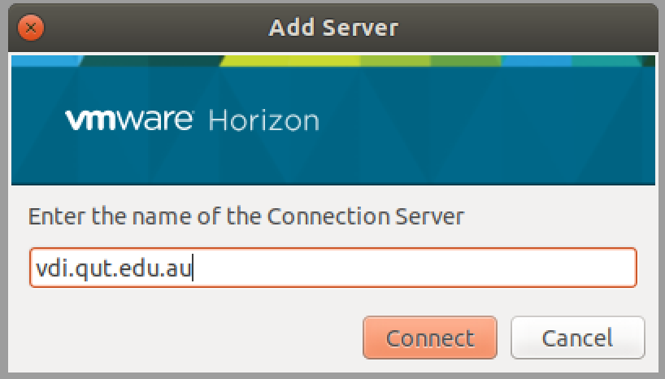

A login window may now appear. Authenticate using your usual QUT login details.

You should now see a selection of machine images. Your list may vary slightly from the one I have below. However, you should be able to see and select the one highlighted: Student – CAB230. Launch it.

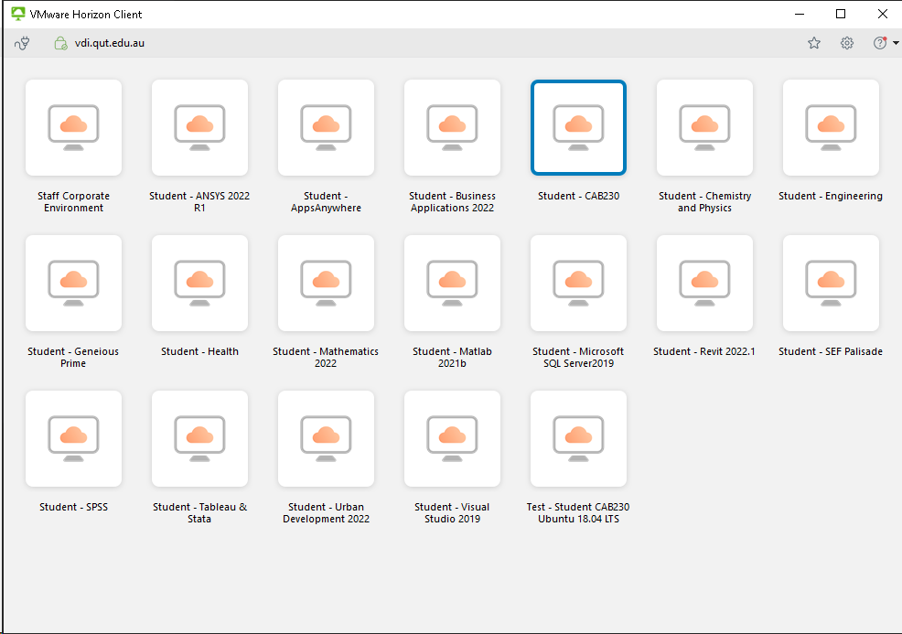

You should now see the Ubuntu login screen. A user account cab230 has been created for you. You will need to enter the password: Cab230! Please note the upper case ‘C’ and the exclamation mark in the password.

If you see the standard Ubuntu desktop background (as below), you have successfully connected to the VM.

**2. IAS Authentication**

In order to connect the VM to the internet, you will need to have QUT access authorisation. On these VMs, this is handled using a dedicated IAS client. Double click the ‘IAClientConfig’ shortcut on the desktop. The client requires your usual QUT login details. The domain is: qut.edu.au

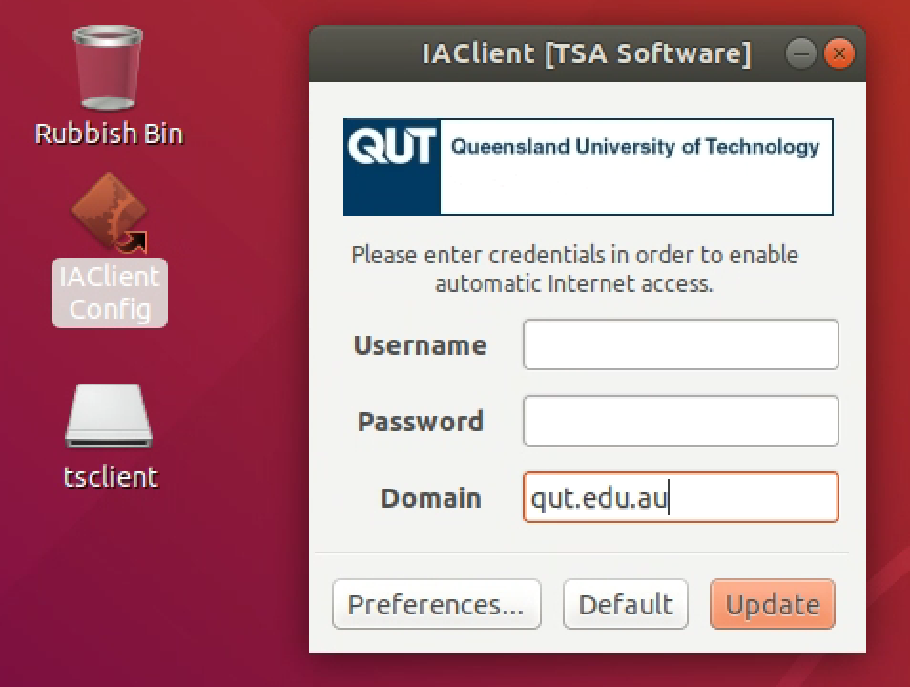

Click update. Your VM should now be able to connect to the internet. Test this by opening Firefox and navigating to a website. Keep in mind that as the VM is within the QUT network, and the machine is not internet facing, only other computers elsewhere on the QUT network will be able to access your machine – we will say much more about this when it comes time for you to deploy your server side assignment.

**3. Using the Ubuntu terminal**

Right click on the desktop and you will see a context menu as shown below. Select the last option ‘Open Terminal’.

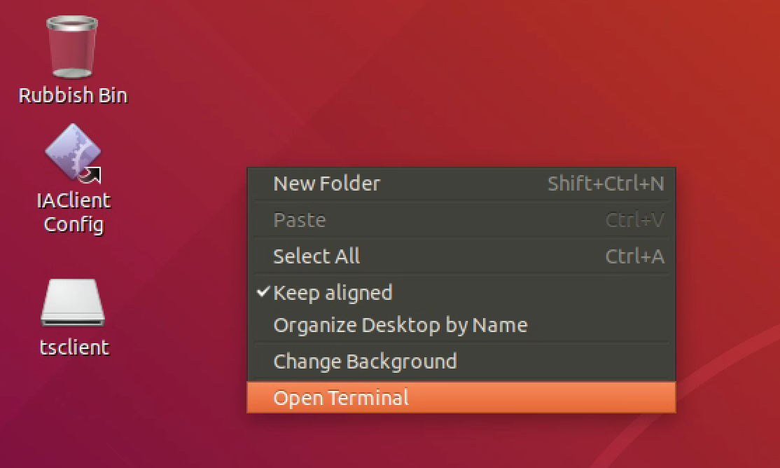

The Linux terminal is a very powerful tool. In this section we will cover some common commands that will help you be productive in the terminal.

The key to understanding the terminal is that you can only be in one place within the filesystem at any given time. This is known as the “working directory”. The prompt indicates which directory you are currently in between the : and $ symbols. Currently you should see that we are in the ~ directory, which is shorthand for the home directory.



To list the contents of the current directory, we can use the ls command. This is the list directories command and the equivalent of dir under DOS.

Commands have things called flags that add more functionality to the command. The ls command has a -l flag. This stands for long and shows the list of files in a long format. The information shown from the left to right is: file permissions, number of links, owner group, file size, timestamp of last modification and file/directory name.

We can see that inside our current directory is a Documents directory. To move into Documents, we can use the cd (change directory) command. We can navigate using the cd command with an absolute or relative path.

An absolute path is a path from the root directory. If you can imagine the filesystem as a tree, the root directory is the directory at the very top of the tree. It is commonly shown as slash (/). When you specify a path that starts with / it means that you are starting from the root directory. For example, the absolute path to the home directory, that we are currently working in, is /home/cab230

Specifying absolute paths can become tedious as you venture further into the filesystem. This is one of the reasons why we have the option of using a relative path. A relative path does not begin from the root directory, instead it begins from where you are currently in the filesystem.

For example, to move into the Documents folder we could use an absolute path:

Or a relative path:

Both paths take us to exactly the same place. For the relative path we can just use the name of the folder (Documents) because we are already in /home/cab230

There are also a number of commonly used shortcuts for relative paths:

* cd .. (parent directory – takes you to the directory above your current working directory)
* cd ~ (home directory – takes you to the home directory i.e. /home/cab230)
* cd – (previous directory – takes you to the directory you were previously just in)

Navigating the filesystem with absolute and relative paths can be confusing at first. At this point I encourage you to practise moving around the filesystem using the terminal.

Assuming we are now back in the Documents directory, the next commands we will cover are touch and mkdir – used for creating files and folders respectively.

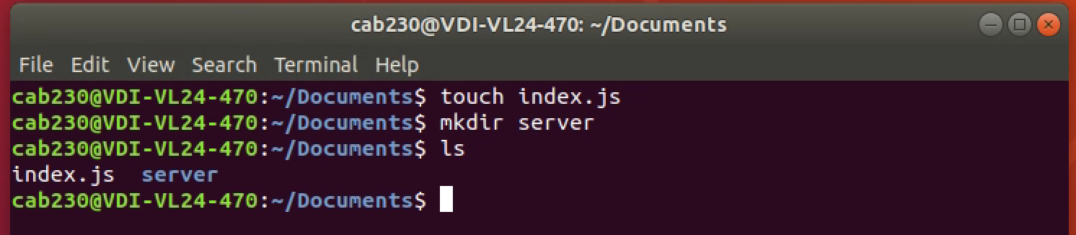

Running the ls command confirms that we have created an empty file named ‘index.js’ and an empty ‘server’ folder. Now we will look at how to remove the file and folder that we have just created. The rm (remove) command is used to delete files and directories.

To remove a file, we can use the rm command along with the file name:

Please exercise caution when using rm. Using the command removes files for good. They are not moved into a trash can or similar. Some important files will be write-protected. However, these too can be removed by using the -f (force) flag that tells rm to remove all files, whether they are write protected or not.

Removing a directory is a little different. The rm command by itself will not work. You must add the -r (recursive) flag to remove any files and subdirectories contained within it.

If you prefix sudo with any linux command, it will run the command with elevated privileges. Sudo stands for “super user do”. Elevated privileges are required to perform certain administrative tasks. If you are familiar with Windows, it is similar to the Windows User Account Control dialog box although there is no pop-up in Ubuntu. Often you will know that sudo is required for a command as the terminal response will be “Access Denied”. As a general rule, try to run commands without sudo first and only use it if elevated permissions are absolutely necessary.

There are many more Linux commands that we don’t have time to cover in this guide. Nor are you likely to need them for this unit. If you find yourself wondering how to do something in the terminal, Google is your best friend.

**4. Setting up a simple HTTP server**

The purpose of this section is to demonstrate how to install a node package globally. We will discuss Node and the Node Package Manager (‘npm’) in depth throughout this semester. For now, it is enough to know that npm allows us to consume open source JavaScript packages. There are over 1 million packages available! Today we will focus on the [http-server package](https://www.npmjs.com/package/http-server).

Node.js and npm come preinstalled on the VM. We can verify this by running their respective -v (version) flags. A response with the version is all that we are after here - your actual version number could be slightly different to the screenshot below.

Before we use http-server, we first need to create a simple webpage to serve. In the terminal, make a new directory called “website” with the mkdir command, cd into the website directory and then run code . (include the full stop!) to open the directory in Visual Studio Code.

Visual Studio Code is our recommended editor for web development. If you feel more comfortable using another editor, you are welcome to use that instead. Like most code editors, VS Code has a typical layout of files and folders on the left, and a code editor on the right. If you would like to learn more about the user interface, check out the [VS Code Getting Started Guide](https://code.visualstudio.com/docs/getstarted/userinterface).

Create three files inside the website folder: index.html, styles.css and script.js

The webpage we will build is a Dr Seuss Quote Generator. The content of the HTML, CSS and JavaScript files are included below. The files have also been uploaded on Blackboard alongside this guide for easier access. Add the contents of each file to your VM using VS Code.

index.html

script.js

styles.css

In short, the JavaScript selects a random Dr Seuss quote from the ‘quotes’ array and displays it on the page. Most of the CSS is used for positioning the quote in the middle of the page using [flexbox](https://developer.mozilla.org/en-US/docs/Learn/CSS/CSS_layout/Flexbox).

Now we are ready to serve the webpage using the http-server package. We have already confirmed that npm is installed on the VM.

NPM packages can be installed locally or globally. Installing a package locally makes it available only to the current project. This is usually the desired behaviour as each project is likely to use different packages. However, in the case of the http-server package, we want to be able to use it as a command in the terminal and we want it to be available for any project on our VM. Therefore, we will install (i) it globally using the -g (global) flag. Note that the use of sudo is also required to install a package globally.

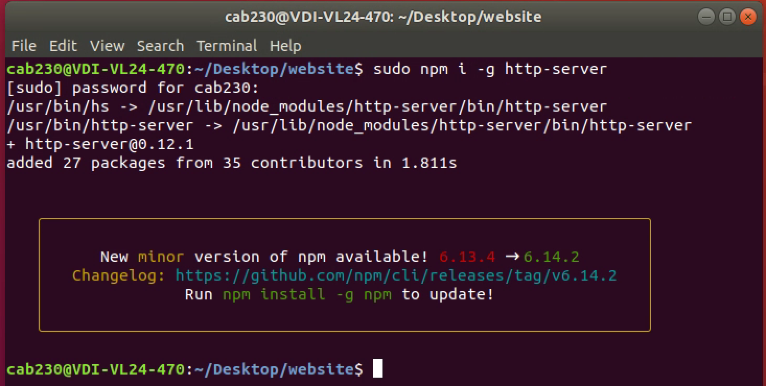

As the package is installed globally, we can now run it in the terminal:

Open up Firefox and go to 127.0.0.1:8080 or localhost:8080 to see the served webpage:

**5. Querying the MySQL database – you may skip this on a first reading.**

MySQL server comes preinstalled on the VM. The installation has been set up as follows:

* Username: root
* Password: Cab230!
* Port: 3306

This section will explain how to connect to your MySQL server, load a sample database and then perform a simple query on the database.

On your VM, download the world.sql file that has been included on Blackboard alongside this guide. This is an example database that includes information about countries in the world, some of the cities in those countries and the languages spoken in each country.

In your terminal, navigate to where you have downloaded the world.sql file. I have downloaded the .sql file to my Desktop.

The command below allows you to login to the SQL server. You should then enter the password Cab230! as discussed above.

You should now see that the prompt has changed to mysql>. This means that we are now working within the interactive MySQL environment.

We will first create an empty database called world. Note that the semicolon (;) at the end of each MySQL command is required.

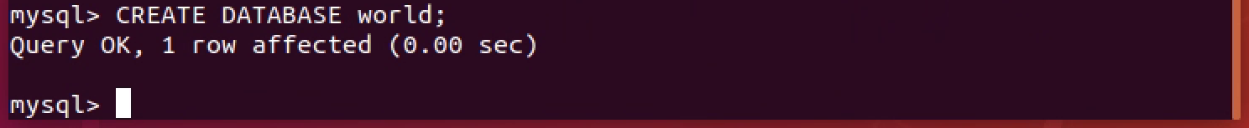

We can now use the world database and import the downloaded .sql file using the source command.



The show tables command lists the tables in the database:

We can now run a simple SELECT query to see what data is in the CountryLanguage table:



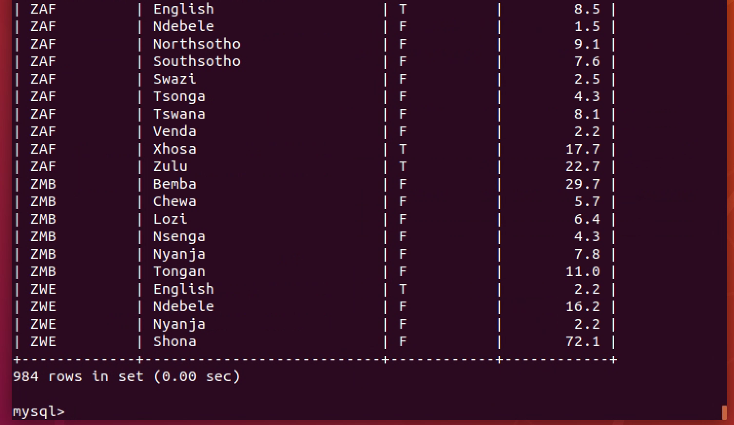

We discuss MySQL in greater depth and explain how to access it from a web application in the practicals. You can leave the MySQL interactive environment using the exit command.

**Setting up React**

Please see the React Setup Guide on Blackboard for how to set up a React development environment on your VM.